Lab Project: Database Development

HAMAREY BACHCHEY

Group Members:

I18-0454 Maria Yasir Sec B

I18-0479 Sameet Asadullah Sec B

I18-0579 Nabeel Danish Sec B

I18-0531 Tayyab Ali Sec D

# ERD:

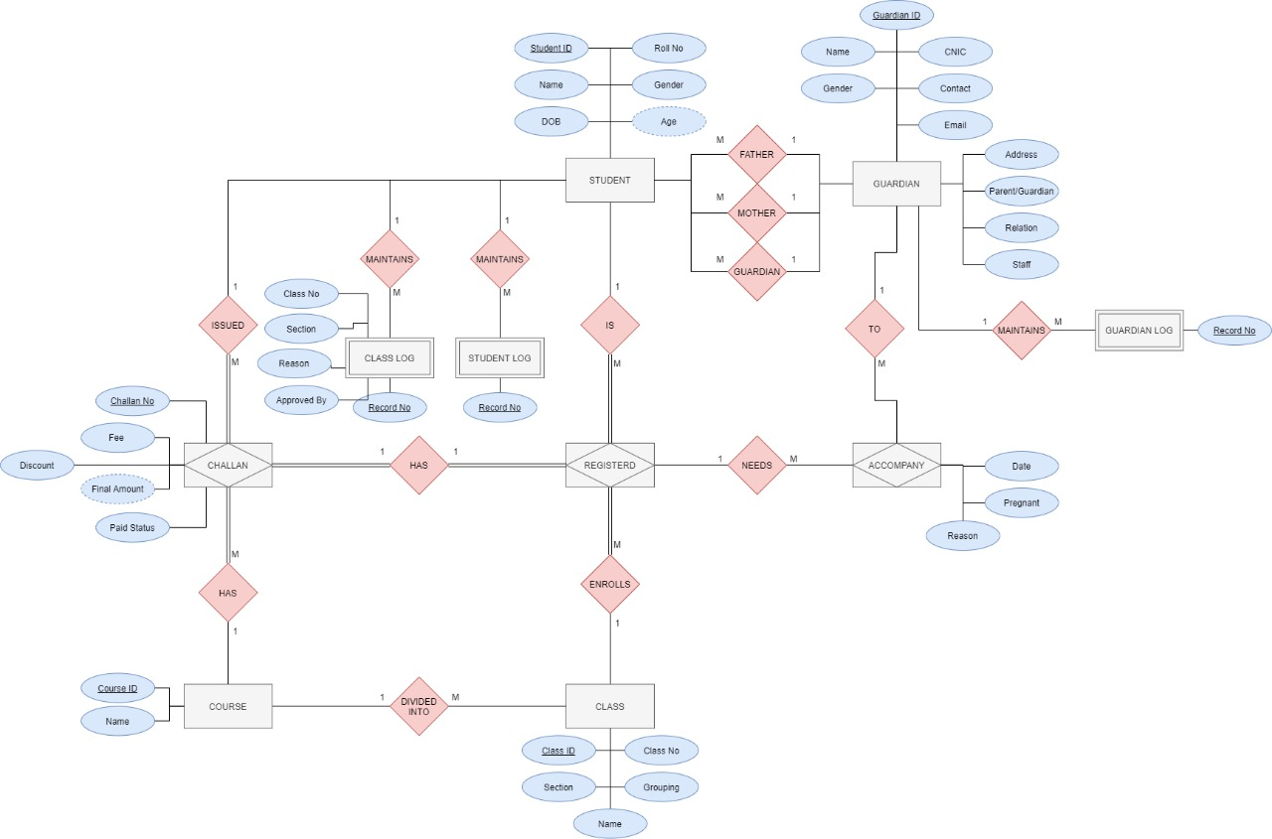

# Explanation:

## Student & Student log:

The name, personal information of a student with their roll no’s and IDs are stores in “STUDENT” table along with IDs of their guardian, father and mother acting as foreign keys.

To store the history if a student updates any information about him whether it’s a personal information or the information of a guardian, a table “STUDENT_LOG” is made to keep all the history in that. It has composite keys of student ID and record No.

Moreover, there are some dormant students who are admitted but have not registered in the current course.

## Guardian & Guardian log:

All the parents and guardians are stored in a single table under the name “GUARDIAN”. It stores the ID, name and personal information of every person who is either a guardian or a parent and also stores the bool value if a person is a parent and a staff member of the organization. This table also stores the relation of a parent and a guardian to its student.

To store the history of any information update of guardian table, there is another table “GUARDIAN_LOG” is made to keep all the changes. It has the composite key of the guardian and record No.

## Course:

The table “COURSE” is made to keep the record of all the courses which are being offered in the organization along with their IDs. For these courses, the initial classes are also being made with one section each.

# Challan and registration:

After a student is been admitted to the organization, the choice to register for a course is still there. If a parent chooses to register the student for the course being offered, a fee challan is generated.

All the information regarding the fee, discount, paid status is stored in the table “CHALLAN”. The triggers are made for the discount for a child of a staff member of the organization and to the students who have more than 3 siblings currently admitted.

The challan no from challan table is then used in the “REGISTERED” table to register a student in the class and section keeping in view of gender and the sections available along with their student ids.

All the record of every student who has been registered in a class for any course along with class ids is stored in this table.

## Class And Class log:

The information of all the classes along with their sections, name and the information about grouping is stored in table “CLASS”.

If class of a student is changed then the updated record is stored in table “CLASS_LOG”.

## Accompanying:

For the students under age 6, the mother has to present for the duration of the classes. If a mother cannot be present, then a guardian has to be present and the table “ACCOMPANY” stores all the information of the guardian, date and reason for the accompanying case.

# 

# Forms and reports (PHP):